## REQUIREMENT ANALYSIS

The purpose of System Requirement in our project is to obtain a thorough and detailed understanding of the business need as defined in Empower Illiterate and to break it down into discrete requirements, which are then clearly defined and reviewed:

### 2.1 Functional Requirements:

* Registration: To view query or to connect with mentor, user and mentor first have to register to the portal. Requirements of registration are Username, Email-Id, Mobile No, Date of Birth, Address and Password
* User Login: Our website will provide user to login into our project by his respective Username and Password.
* User Logout: Our website will provide user to logout from their account after their session is done.
* Post articles: user can view the articles uploaded by the mentor.
* Query: user can ask queries to mentor in this module.

Modules of the system

## Admin:

* Admin can view the details of the Mentor.
* Admin can activate or deactivate Mentor account.

## User:

* Performs registration and login actions in the application.
* He can post, delete and view articles.
* He can view and reply query’s

### 

### Mentor:

* Performs registration and login actions in the application.
* He can search for mentor.
* He can send, delete and view query.
* He can view articles.

### 2.2 Non-functional requirements

* + - **Performance Requirements**

This system is developed in high level languages and used advanced front end and back end technologies. It generates response in less time.

## Safety Requirements

No harm is expected from the use of the product either to the OS or any data that resides on the client system.

## Product Security Requirements

The product is protected from unauthorized users from using it. The system allows only authenticated users to work on the application. The user of the system is Admin and user.

### 2.3 Computational Resources:

* + 1. **Software Requirements:**
* Operating system : Windows 10
* Web server : Apache Tomcat 7.0
* Client-Side Technologies : HTML, CSS, Java Script
* Data Base Server : MYSQL
* Server-Side Technologies : JSP

### 2.3.2 Hardware Requirements:

* + - Operating System : Microsoft Windows 10
    - Processor : I3
    - RAM : 4GB
    - Hard Disk : 500GB

## Life Cycle Model

It is also referred to as a Linear-sequential life cycle model. It is very simple to understand and use. In a waterfall model, each phase must be completed fully before the next phase can begin. This type of software development model is basically used for the project which is small and there are no uncertain requirements. At the end of each phase, a review takes place to determine if the project is on the right path and whether to continue or discard the project. In this model, software testing starts only after the development is complete. In waterfall model, phases do not overlap.

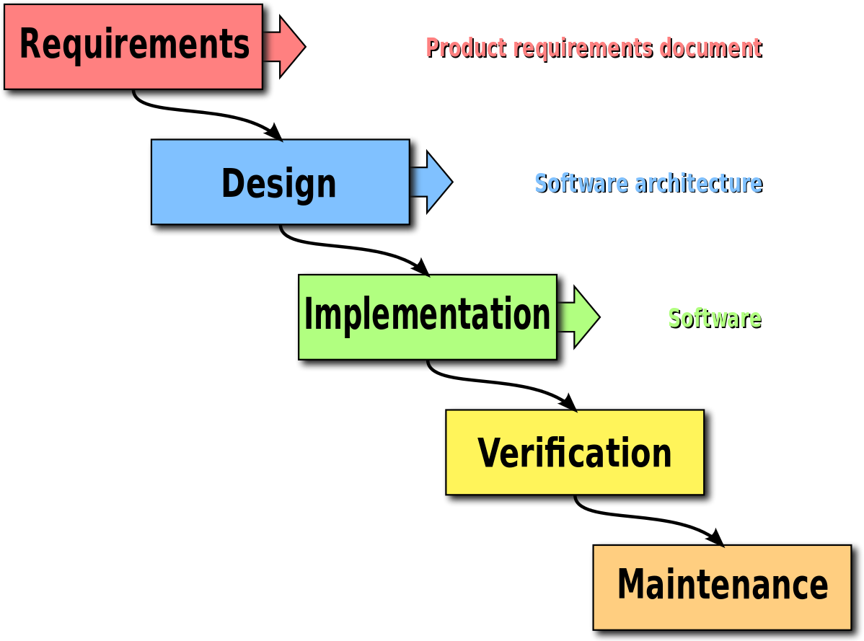

Figure 2.1 Life cycle model

### Advantages of waterfall model:

* This model is simple and easy to understand and use.
* It is easy to manage due to the rigidity of the model – each phase has deliverables and a review process.
* In this model phases are processed and completed one at a time. Phases do not overlap.
* Waterfall model works well for smaller projects where requirements are very well understood.
* Because it was created in a time when no formal software development methodologies existed, this hardware-oriented model was simply adapted for software development.